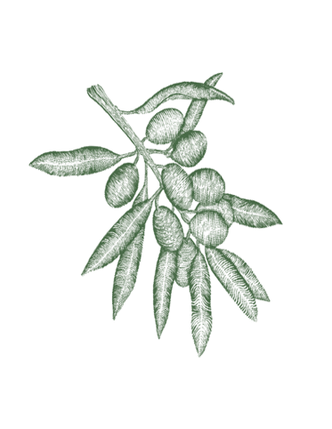

Small

house made focaccia with olive oil & balsamic • 4.5
Sicilian green olives • 8
eggplant & provolone polpette, aioli, sugo (gf) • 18
salsa di fagioli bianchi (white bean dip), pickles, sourdough (vgn) • 17
Spanish anchovies on sourdough toast with whipped
lemon confit garlic ricotta * • 15
Burrata with olive XO & focaccia • 23
Villa Culatello Proscuito di Parma 18mth & parmesan • 25

Large

Insalata della casa • 24
Gnocchi with pumpkin, parmesan, burnt butter, sage & pine nuts * • 25
Puttanesca - tagliatelle, tomato, capers, olives, chilli & anchovies c• 25
Tagliatelle -pork & fennel sausage, garlic, white wine, chili, cime di rapa *• 25

$30 LUNCH DEAL – A CHOICE OF EITHER PASTA & A GLASS OF HOUSE VINO

Sides
twice cooked chats, rosemary, garlic aioli (vo) • 12
Victorian leaf salad, muscatel dressing • 15

* Gluten free option, (vo) vegan option
**GLUTEN INTOLERANCE: We take a lot of care in crafting our gluten free range, however, we cannot totally avoid cross-contamination of wheat flour as it is used in large quantities daily in our kitchen.

