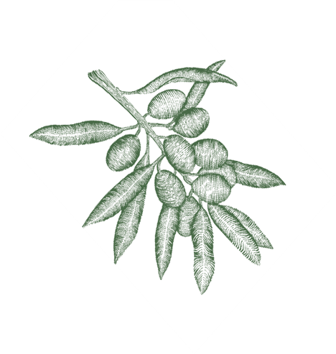

SNACKS

Mixed salted nuts • 6.5
House made focaccia with olive oil & balsamic • 4.5
Sicilian marinated green olives • 9

SMALL PLATES
Cantabrico anchovies on toasted sourdough, whipped lemon & thyme ricotta * • 15
Crema di fagioli - white bean dip, house pickles, toasted sourdough * (vgn) • 17
Eggplant & provolone polpette, aioli, sugo (gf) • 18
Proscuito di parma & parmesan • 25
Cured Tasmanian ocean trout, butter milk, mint, cucumber, jalapeño, Yarra valley caviar (gf) • 26
Burrata with olive XO & focaccia * • 25
Charred broccolini, confit garlic & preserved lemon, salt bush (gf) • 18

PASTA “Fata a mano” All our pasta is handmade.
Agnolotti of ricotta & asparagus, new season peas, pea shoots, split garlic chive butter sauce. pangrattato • 37
Puttanesca - pappardelle, tomato, capers, olives, chilli & anchovies * (vo) • 33
Tagliatelle with Prawn and Artichoke * • 37

M A I N S
Whole market fish, herb & pickled shallot salad, lemon • Market price
Slow roasted saltbush lamb shoulder, heirloom carrots, jus (gf) • 42

S I D E S
Twice cooked chats, rosemary, garlic aioli (vo) (gf) • 12
Finocchio – shaved fennel, green olives & provolone • 17
Victorian leaf salad • 15

* Gluten free option, (vo) vegan option
**GLUTEN INTOLERANCE: We take a lot of care in crafting our gluten free range, however, we cannot totally avoid cross-contamination of wheat flour as it is used in large quantities daily in our kitchen.

D E S S E R T S
Tiramisu • 16
Chocolate mousse, crispy buckwheat, EVOO (gf) • 16
Fig leaf panna cotta, pistachio & pepper wheat crumb* • 16

C H E E S E S
WOOMBYE ASHED BRIE (QLD) • 16
slightly smoky & mushroom flavours, served with Mornington honey
TARAGO SHADOWS OF BLUE (EASTERN VIC) • 16
mild with a sweet blue flavour
LONG PADDOCK BANKSIA (VIC) • 16
An organic cow’s milk cheese with a creamy, sweet, nutty earthy tones, becoming more pungent and brothy, umami with age

THREE CHEESE PLATTER • 35

S T I C K Y W I N E S & A M A R I
Gewurztraminer, Delatite 2019, VIC • 15/60
Noble Taminga Reserve, Trentham 2015, VIC • 10/44

If you haven’t tried one of these Italian bitters, the time is now!
Amaro straight or on ice with a wedge of orange is the perfect finale.

Averna Amaro, ITA • 14
Lucano Amaro, ITA• 14
Montenegro Amaro, ITA• 14
Autonomy Amaro, AUS• 14
Cynar, ITA• 14

Don Giovanni Limoncello, ITA• 12
Strega, ITA• 12
